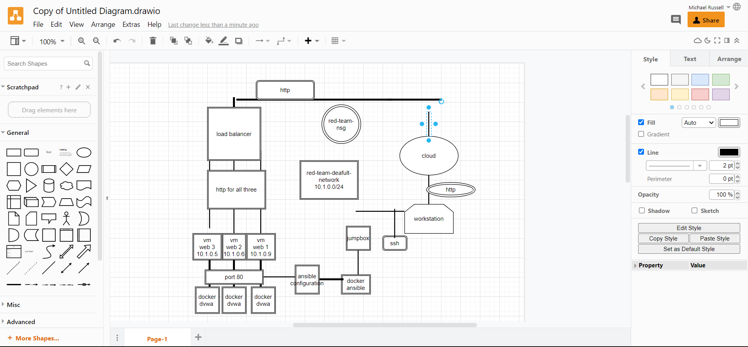

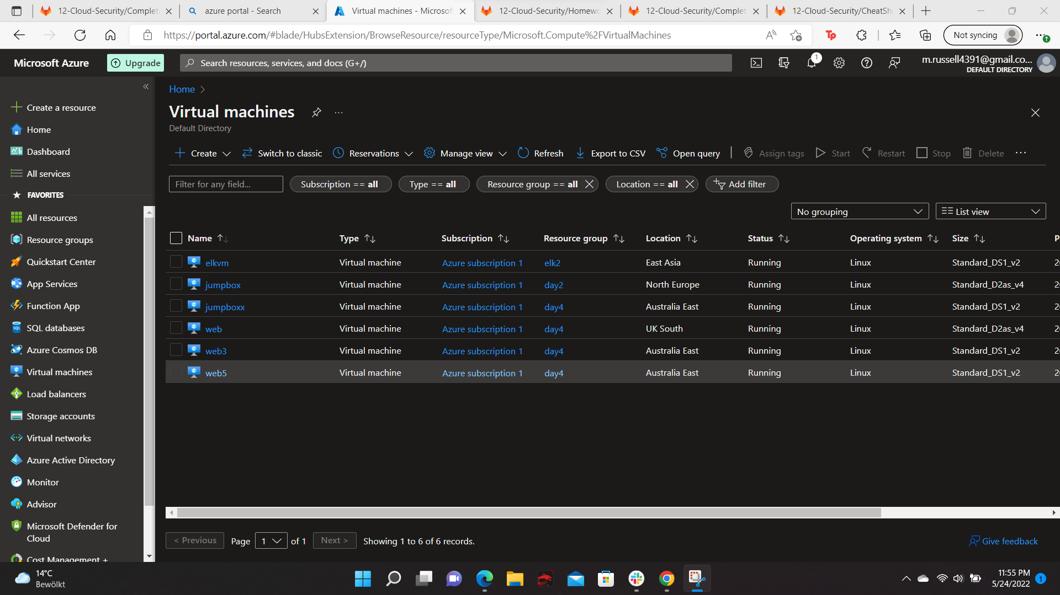
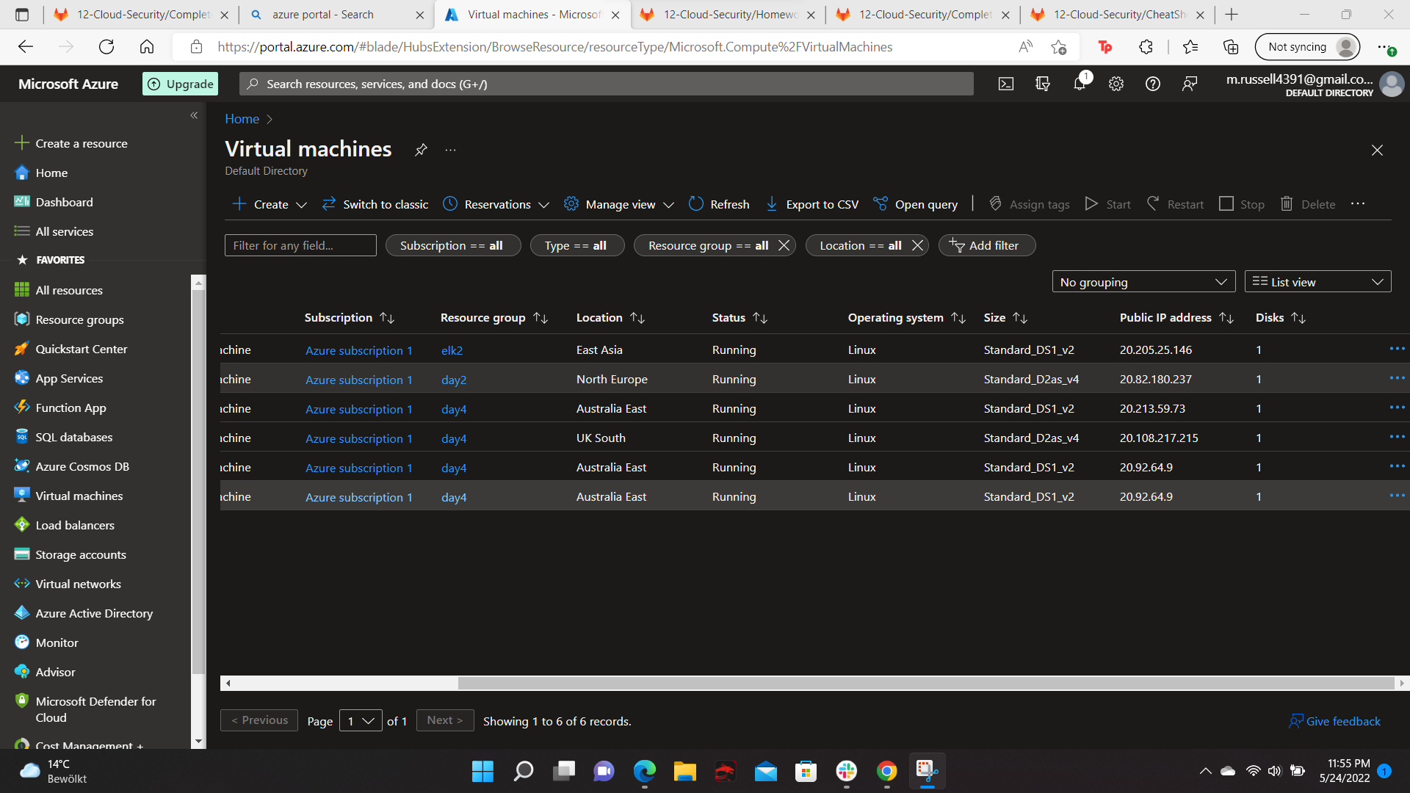
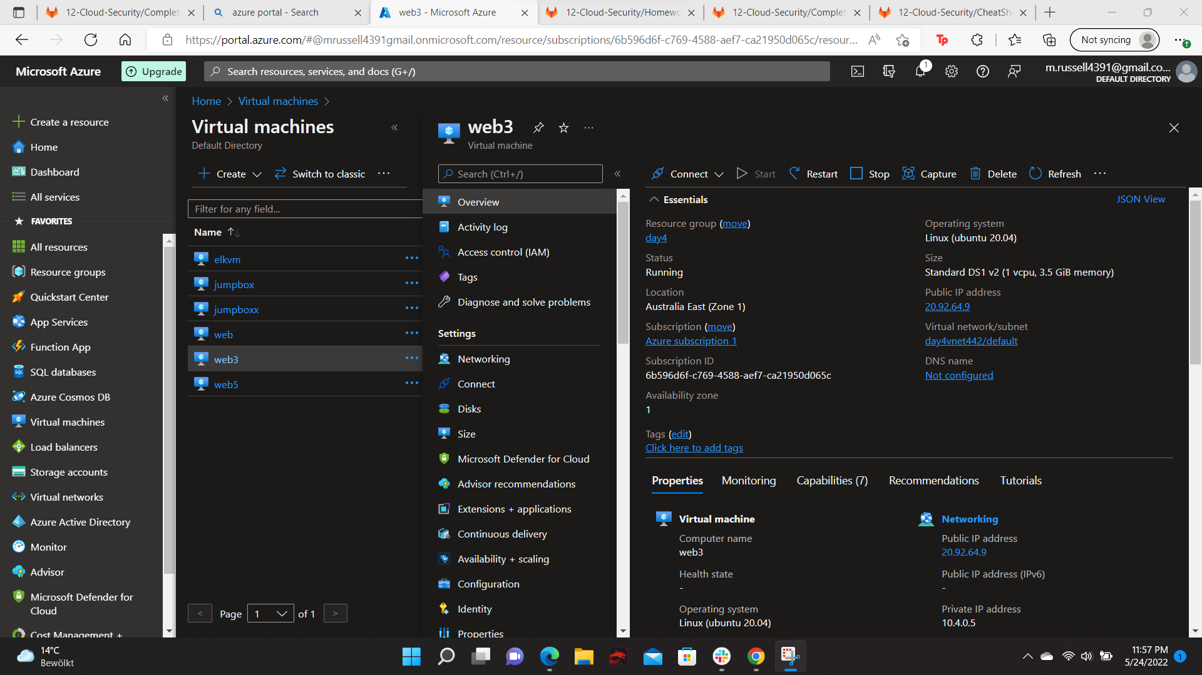
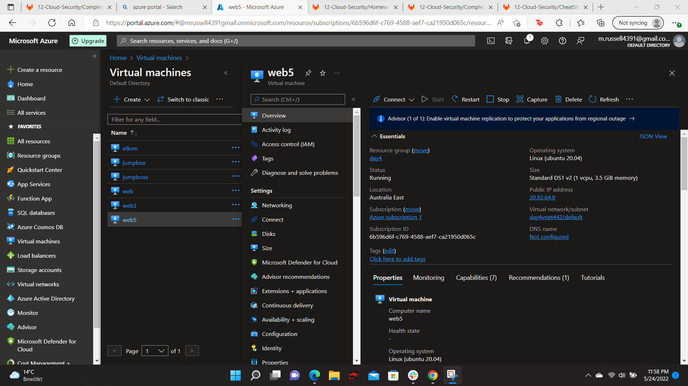
Your diagram should show the following:
- Azure resource group day 4
- Virtual network with IP address range 20.92.64.9
- Subnet range day4vnet442/default
- Flow of specific traffic (e.g., HTTP, SSH) http
- Security group blocking traffic web2-nsg
- Load balancer
- All 4 VMs that you have launched - web3 and web5
- Where Docker and Ansible are deployed

